PavlOS Developer Documentation

Content

Start 1

Design 1

Overview 1

# Start

To create apps in PavlOS, you'll need to have knowledge of **JSON** and our Pavl+ **language.** If you do not know how to program in Pavl+ so do not despair, we will teach you.

You're going to need a text editor. We recommend **Notepad** or Visual **Studio Code**. Maybe we already have our own editor or compiler for Pavl+ at this time, so you can use it.

# Design

## Overview

The design is created in JSON data files. If you have already created programs in Win UI in XAML, our system in JSON is very similar. In the next part of this chapter, we will show you what design creation looks like.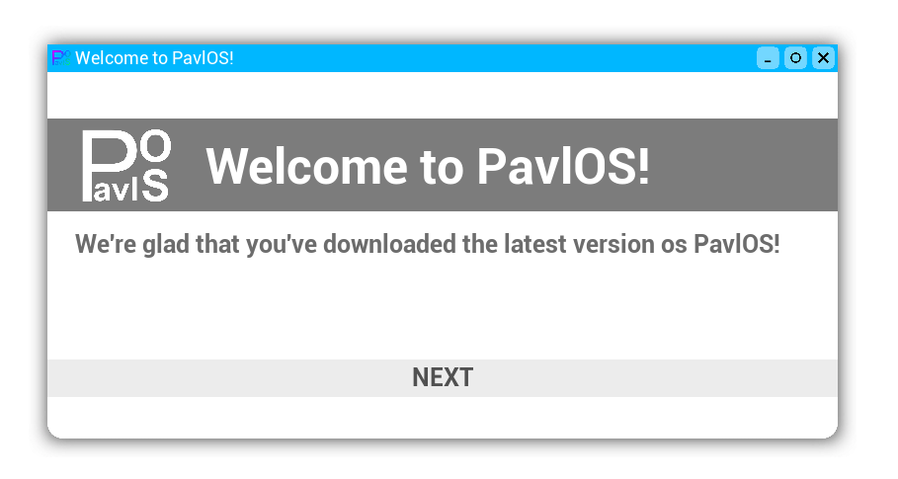

## JSON Design

Our design at JSON consists of a few sections.